Daffodils - William Wordsworth: key word mat (use as is) / matching activity (cut up)

daffodils | 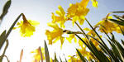 | Yellow, bell-shaped flowers that are commonly seen in the spring
crowd |  | A large group of people  you don’t know
cloud |  | A grey or white mass in the sky made up of very small floating droplets of water
o’er | 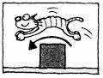 | An old-fashioned way of saying ‘over’
vale | 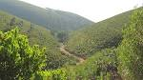 | Another way of saying ‘valley’
bliss |  | Extreme happiness
solitude |  | Being alone or on your own
inward eye |  | You use this to look at the pictures in your mind when you are remembering
margin | 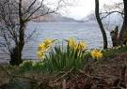 | The outer edge of something
bay | 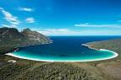 | A place where the sea is surrounded  by land on three sides
tossing | 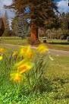 | Moving very quickly up and down  or side to side
sprightly | 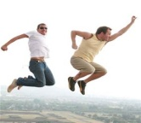 | Lively or energetic
glee |  | Excitement or pleasure
gay |  | An old-fashioned way of saying ‘happy’
jocund |  | Another way of saying ‘happy’
company |  | A group of people or things  that you are together with
wealth | 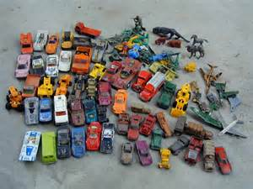 | A large amount of something  (such as pleasure or toys)
couch | 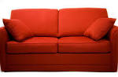 | Another word for ‘sofa’ or ‘settee’.  A long comfy seat with cushions
vacant |  | When a person is not busy  When something is empty or not occupied
pensive |  | Describes how you are when you are  thinking about something or someone
continuous |  | Without pausing or stopping
wander |  | To walk around slowly  in no particular direction
breeze |  | A light wind
lake | 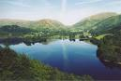 | A large area of water surrounded by land that is connected to the sea by a river
gaze | 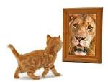 | To look at someone or something  for a long time
Milky Way | 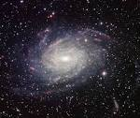 | A wide band of millions of stars in the sky  Our sun is one of these stars

